MEMBERSHIP APPLICATION FORM
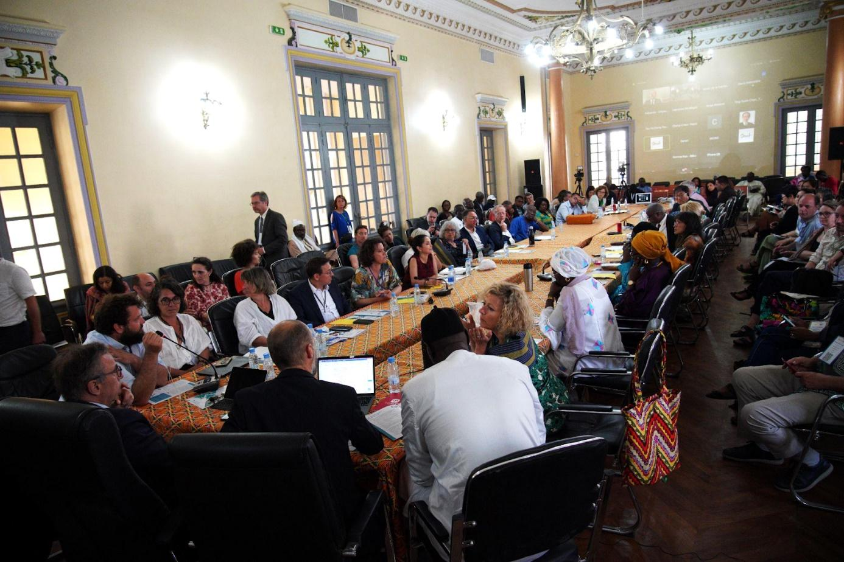

GSEF General Assembly in Dakar, May 5th 2023

1. Membership Information (page 2)
2. Membership Application Form (page 6)
3. GSEF Charter (Annex)

I. MEMBERSHIP INFORMATION

INTRODUCTION
The Global Forum for Social and Solidarity Economy (hereinafter referred to as “GSEF”) is a global Social and Solidarity Economy (SSE) network that aims to serve as a hub for sharing visions and experiences through collaboration across borders and cooperation based on multilateral (public-private-community) partnerships for an inclusive, equitable and human-centered world.
The development of GSEF began with the Seoul Declaration, which was adopted by eight local governments and nine SSE organizations during GSEF2013, held in Seoul from November 5 to 7, 2013 on the theme ‘New Discovery of Collaboration’.
Following this first successful event, GSEF has held, since 2014, biennial international forums hosted by its member cities across the continents. GSEF2014 was organized in Seoul with the founding General Assembly of GSEF to pursue the global expansion of knowledge-sharing and cooperative relationships among social economy actors. The 3rd edition of the forum, GSEF2016, which took place in Montreal on the subject of ‘Local governments and social economy stakeholders – allies for the intelligent and sustainable development of cities,’ was a very important milestone for the global visibility and expansion of the GSEF network. These forums are one of the most prestigious international gatherings on SSE, bringing together all levels of stakeholders, from international organizations, local/central governments, and civil society networks, for mutual learning, agenda setting, and knowledge exchanges.
GSEF2018 took place in the city of Bilbao under the theme ‘Values and competitiveness for an inclusive and sustainable local development’. It gathered over 1,700 participants from 84 countries and successfully strengthened the momentum toward advancing the international agenda on SSE.
GSEF2021 was held in Mexico City in a hybrid format. It showcased creative ideas and visions, practical proposals, and collaboration opportunities about how SSE can contribute to building inclusive and sustainable societies for everyone as a response to the current important momentum of political and social changes arising globally.
GSEF2023 took place in Dakar and gathered 6,000 participants over six days. It included for the first time two special events: the Youth & SSE Pre-Forum and the Women’s Day for SSE. The forum addressed a cross-cutting theme: the transition from “informal” economies to collective and sustainable economies for our territories.
GSEF accompanies local governments across the world in the collaboration process with SSE actors toward the co-creation of public policies and the establishment of sustainable ecosystems conducive to the development of SSE.
GSEF’s long-running series of regional policy dialogues on different continents, including Asia, Africa, Europe and Latin America, is a good example of local governments and SSE actors gathering and discussing under common agenda and goals.
As of July 2023, GSEF brings together 84 members from 36 countries on all 5 continents, including 32 local governments, 27 SSE networks and 25 SSE organizations/enterprises. As a GSEF member, you can share your experiences and learn from others, expand your network, and discuss best practices through different GSEF programs.
We look forward to welcoming you to the GSEF network! For detailed information about GSEF membership, please refer to the following information.
I- MEMBERSHIP CATEGORIES
1. Full Membership (with voting rights)
It is open to local governments and SSE networks as detailed below.
- The Local Government membership: open to any local autonomous entity, government, and association at both the local and national level.
- The Social and Solidarity Economy Network or Organization membership: open to any regional, national, continental, and worldwide network or organization working in various fields of SSE including supporting organizations and associations.
A full member possesses the right to vote and is eligible to run for election.
2. Associate Membership
Open to any SSE organization wishing to actively participate in GSEF’s activities and benefit from its networks.
Associate members do not have the right to vote and are not eligible to run for election.
3. Honorary Membership
Offered to individuals or organizations that have made a notable contribution to diverse SSE sectors and/or GSEF’s activities. Candidates for honorary membership shall be nominated by the GSEF Steering Committee and approved by the General Assembly.
4. Partners
Partners include intergovernmental organizations, national governmental agencies, and civil society and private sector organizations working with GSEF in a broader sector including social economy and appointed by the GSEF Steering Committee.

II- APPROVAL AND WITHDRAWAL OF MEMBERSHIP
Approval
Membership applications are reviewed by the GSEF Secretariat and submitted for decision to the GSEF Steering Committee.

Withdrawal
A member may withdraw its membership by informing the GSEF Secretariat in writing.

Warning and Disqualification
The GSEF Steering Committee may take the necessary steps to decide on the disqualification of a member if that member is harming or contravening the vision, mission, objectives, and/or the Charter of GSEF. The GSEF Steering Committee shall go through the designated formalities to disqualify the member.

III- BENEFITS AND RESPONSIBILITIES OF MEMBERS
Membership Benefits:
- Become a part of a solid and recognised SSE network.
- Access a platform to connect with other members and SSE players in your country and worldwide.
- Exchange ideas on best regional practices from around the world and receive sound advice on how to implement them.
- Acquire tools and the support of renowned experts with local and regional knowledge to build a global strategy for the development of SSE in your region.
- Make your voice heard on regional, national and international scenes and contribute to the development of agendas.
- Participate in GSEF’s decision-making processes.
- Boost the visibility of your organization and promote your activities through GSEF’s communication means.

Membership Responsibilities:
- Support and collaborate on GSEF’s projects and activities.
- Practice solidarity in the exchange of experiences, knowledge and information for the development of SSE ecosystems.
- Promote the importance of collaboration and co-construction among local governments and Social and Solidarity economy actors.
- Pay an annual fee to contribute to GSEF’s activities at the service of all members.

IV- MEMBERSHIP FEES
Members are required to pay an annual membership fee starting from the year immediately following the year when they become members of GSEF. Membership fees vary depending on the population and the GDP per capita of the country from which the member originates or where the duly authorized government office is based. Please find below the membership fee table (in USD).

- Full Member - Local government membership fee
Population (‘000) |  | 0~999 | 1000~4999 | 5000~9999 | 10000~
GDP per capita (USD) | 0~999 | 300 | 400 | 500 | 600
 | 1000~9999 | 1000 | 1500 | 2000 | 2500
 | 10000~14999 | 2000 | 4000 | 6000 | 8000
 | 15000~ | 4000 | 6000 | 8000 | 10000

- Full Member – Social and Solidarity Economy network membership fee
Population (‘000) |  | 0~999 | 1000~4999 | 5000~9999 | 10000~
GDP per capita (USD) | 0~999 | 50 | 70 | 80 | 90
 | 1000~9999 | 100 | 130 | 150 | 180
 | 10000~14999 | 200 | 300 | 400 | 500
 | 15000~ | 300 | 500 | 750 | 1000

- Full Member – Regional and International SSE Network membership fee
# of countries where members are located | Membership fee
0~9 | 500
10~29 | 1000
30~49 | 1500
50+ | 2000

- Associate Member: 50% of full members’ fee

Note1. The latest World Economic Outlook Database published by the International Monetary Fund* shall be applied in calculating the GDP per capita in the table above. The GDP per capita is based on purchasing power parity. Note2. The membership fee amount in any given year is determined based on the GDP of the year immediately preceding the previous year. Note3. Once approved, all members are eligible for one year of membership fee grace period. Once the grace period ends, annual membership fee applies the next fiscal year onward. Note4. The population figure used for the calculation of local governments’ membership fee shall be based on their respective city population, while the membership fee of national SSE networks shall be calculated on the basis of the total population of their respective country. * The latest World Economic Outlook Database published by the International Monetary Fund can be found at IMF website.
II. MEMBERSHIP APPLICATION FORM

1. MEMBERSHIP CATEGORY
Please tick the membership category for which you are applying.
☐ | Full Membership
 | A full member possesses the right to vote and is eligible to run for election. It is open to local governments and social and solidarity economy networks and organizations as detailed below.
 | ☐ | Local government membership
 |  | is open to any local autonomous entity, government, and associations at both the local and national level.
 | ☐ | Social and Solidarity Economy Network or Organization membership
 |  | is open to any regional, national, continental, and worldwide networks and organizations working in various fields of SSE including supporting organizations and associations.
☐ | Associate Membership
 | is open to any local government and SSE organization wishing to actively participate in GSEF’s activities and benefit from its networks.
 | Honorary Membership**
 | is given to an individual or an organization that has made a notable contribution to diverse SSE sectors and/or GSEF activities. An honorary membership shall be nominated by the GSEF Steering Committee and be approved by the General Assembly.
 | Partner**
 | Partners include intergovernmental organizations, national governmental agencies, and civil society and private sector organizations working with GSEF in a broader sector including SSE and appointed by the GSEF Steering Committee.
** If you or your organization wishes to be considered for an Honorary Membership or to join as a Partner, please contact the GSEF Secretariat, for these two categories are appointed by the GSEF Steering Committee.

Please provide the following information required to calculate the amount of the membership fee. You can check your index on the following website : World Economic Outlook Databases

Name of the City / Country
Population
* If you are a local government, please indicate the population of your city. If you are an SSE network/enterprise/organization, please put the latest statistics of your country population.
GDP per capita based on PPP (USD)

2. CONTACT DETAILS
Organization General Information
Official Organization name
Acronym
(if applicable)
Registered Office Address
(include city and country)
Telephone No.
(include area code)
Email address 1
Email address 2
Website
Social networks
Main language  (single choice) | ☐ | English | ☐ | French | ☐ | Spanish
Secondary language  (single choice) | ☐ | English | ☐ | French | ☐ | Spanish
Organization type  (single choice) | ☐ | Local Government
 | ☐ | Government institution / State agency
 | ☐ | University or research institute
 | ☐ | Social finance institution
 | ☐ | NGO / Association
 | ☐ | Foundation
 | ☐ | Mutual
 | ☐ | Cooperative
 | ☐ | Social enterprise
 | ☐ | Local government network
 | ☐ | SSE actors network (CSO)
 | ☐ | Research network
 | ☐ | Social/solidarity-based finance network
 | ☐ | Multi-stakeholders network (Actors & Local Governments)
 | ☐ | Individual personal
Scale of action  (single choice) | ☐ | Local
 | ☐ | National
 | ☐ | Regional (several countries)
 | ☐ | International (several continents)

Legal Representative
 | ☐ | Ms. | ☐ | Mr. | ☐ | Different title, specify :
First Name
Name
Position / Title
Term of Office | (mm/dd/yyyy) – (mm/dd/yyyy)
Telephone No.
(include area code)
Email address 1
Email address 2

Focal point n°1 for Liaison with the GSEF Secretariat
 | ☐ | Ms. | ☐ | Mr. | ☐ | Different title, specify :
First Name
Name
Position / Title
Telephone No.
(include area code)
Email address 1
Email address 2

Focal point n°2 for Liaison with the GSEF Secretariat
 | ☐ | Ms. | ☐ | Mr. | ☐ | Different title, specify :
First Name
Name
Position / Title
Telephone No.
(include area code)
Email address 1
Email address 2

3. SIGNATURE
☐ | I guarantee that the information provided in this document is accurate.
☐ | I certify that I have read the GSEF Charter (in the annex) and that the organisation I represent accepts its terms.

Signature of legal representative
Name
Position / Function
Date

Some Important Notes
- In cases of applications submitted by local governments, the signature of the mayor or of the appropriate delegation only is considered to be valid.
- In cases of applications submitted by SSE network/organization/social enterprises and others, the signature of the head of the organization/network/enterprise or of the appropriate delegation only is considered to be valid.

4. OTHER QUESTIONS

1. Please briefly describe the current status of your city/organization in relation with SSE. You may also provide us with more information such as legal status, governing rules, ongoing activities, and plans in terms of SSE.

2. How did you get to know GSEF ?

3. What do you expect from joining GSEF?

4. How would you like to collaborate with GSEF?

5. Please list any other membership or network to which you are affiliated.

6. If any, please attach the recommendation letter from the existing GSEF member.

Note: Membership applications are reviewed by the GSEF Secretariat and submitted for decision to the GSEF Steering Committee. The whole registration procedure is detailed in a separate clause.
Please send the completed membership application form via e-mail, mail or fax to the GSEF secretariat, at gsef@gsef-net.org. After receiving the application, the GSEF staff shall contact you regarding the membership fee.

Applicable to Full membership only

